

**Management of COVID-19 case in Pharmacy, Optometry and Dentistry primary care settings**

**Aim**:

To ensure a consistent approach to management of cases/outbreaks of COVID-19 in pharmacy optometry and dental primary care settings, including notification of relevant bodies and the role of the setting/practice in identifying and advising contacts where necessary.

**Context**:

*NHS Test and Trace*

The NHS Test and Trace service aims to trace the spread of the virus and isolate new infections. Anyone who develops symptoms of COVID-19 must self-isolate (along with other members of their household) and is asked to order a test to find out if they have COVID-19. If they test positive, they will be contacted by NHS Test and Trace and asked to share information promptly about their recent contacts so that other people who may need to self-isolate can be alerted. If a healthcare worker is confirmed to be a positive case, it is important that they declare that they are a healthcare worker when contacted by NHS Test and Trace.

*NHS Test and Trace in relation to healthcare settings*

NHS Test and Trace operates a 3-tier system. Where it is known that the case is a healthcare worker (HCW), those cases will be dealt with by Tier 1 which includes Public Health England’s (PHE) local Health Protection Team (HPT). The HPT will receive notification of the case and contact the setting and support the healthcare team to identify and provide advice to the healthcare-related contacts of the positive case (as detailed below). Other contacts of the positive case, for example household or social contacts, will be managed separately via Tiers 2 and 3.

*Notification*

COVID-19 is a notifiable disease. Healthcare providers should notify PHE of any confirmed cases. NHS primary care providers should also inform their local NHS England and NHS Improvement (NHS EI) commissioning team of any likely interruptions to service delivery. PHE will share information about local cases with the Local Authority Director of Public Health.

**Definitions**:

**Symptoms:** the main symptoms of coronavirus are a high temperature, a new continuous cough or a loss/change to the sense of smell or taste

**Case**: a confirmed case is laboratory positive case of COVID-19 with or without symptoms

**Contact\***: a person who has been close to someone who has tested positive for COVID-19 anytime from 2 days before the person was symptomatic up to 10 days from date of onset of symptoms (this is when they are infectious to others). In situations where someone has tested positive for COVID-19 but has not had any symptoms, a contact would be a person who has been close to them anytime from 2 days before the date of test to 10 days after the date of test. For example, a contact would include individuals who:

* Are household contacts
* Have been within a metre of a positive case for a minute or longer
* Have been within 2 metres of a positive case for 15 minutes or longer
* Have travelled in a small car with a positive case

*Please note - contacts of a confirmed case need to self-isolate for 14 days from their last contact with the case.*

**Outbreak**: Two or more confirmed cases linked in time, place and person.

*\*Please note:*

*- if the appropriate PPE has been worn properly during an encounter with a case, the staff who came into contact with the case would not need to self-isolate for 14 days. If there is any question about a breach of PPE, then the exposure would need to be risk assessed.*

*- healthcare workers who have undergone COVID-19 antibody testing and received a positive result must still comply with any instructions to self-isolate as it is not yet known whether a positive antibody test demonstrates immunity.*

*- face coverings are not considered PPE and therefore if a person (staff or patient) came into contact with a case (staff or patient) whilst wearing face coverings, they would be considered a contact and would need to self-isolate for 14 days.*

*- there is no guidance supporting immediate mass testing of all staff when informed of a positive case as even if staff test result returns negative, they will still have to self-isolate for 14 days if identified as a contact as the incubation period is from 1 to 14 days.*

**Process**:

1. **Staff member develops symptoms of COVID-19**
   1. The symptomatic staff member should follow the stay at home guidance <https://www.gov.uk/government/publications/covid-19-stay-at-home-guidance>
   2. They should not attend work and should notify their place of work immediately
   3. If they are at work, they should put on a surgical face mask immediately, inform their line manager (or appropriate person) and return home.
   4. The staff member should be tested for COVID-19. Testing is most sensitive within 3 days of symptoms developing. Tests can be requested by calling 119 or online via this website: <https://www.gov.uk/guidance/coronavirus-covid-19-getting-tested>
   5. If staff absence is likely to impact on service delivery, the pharmacy/practice manager or other appropriate person must notify NHS EI (by completion of the **Notification of COVID-19 service disruption and/or outbreak in Primary Care form** via the following link) <https://forms.office.com/Pages/ResponsePage.aspx?id=kp4VA8ZyI0umSq9Q55CtvxHcP71skKxDgA-0H2yj0aVURDBDMzE0NE5aRFhSQ0MwSFhaQ0RQSDhaMS4u>

If steps can be taken to mitigate this (eg part time staff increasing their hours temporarily to ensure no interruption to service delivery), there is no requirement to inform NHS EI that staff have developed symptoms of COVID-19.

* 1. If the affected person tests negative, they can return to work when they are medically fit to do so. For return to work guidance, see Appendix 1 – Return to work flowcharts: <https://www.gov.uk/government/publications/covid-19-management-of-exposed-healthcare-workers-and-patients-in-hospital-settings> **This only applies to individuals who were tested due to having COVID-19 symptoms. It does not apply to individuals who have been tested because they were identified as a contact of a positive case; these individuals still need to complete their 14 days of self-isolation, even if they test negative within that period. Please note that most people who are identified as contacts of a positive case will not be tested, unless they become symptomatic. PHE may however request additional testing in certain situations.**
  2. If the affected person tests positive, please follow the process detailed in step 2 below for a staff member diagnosed with COVID-19.

1. **Staff member diagnosed with COVID-19**
   1. The staff member who is a positive case must follow the ‘Stay at Home’ guidance and immediately self-isolate at home for at least 10 days from when symptoms started (or 10 days from when the test was taken if asymptomatic). Any other members of staff who live in the same household as the case must also immediately self-isolate at home for 14 days and not present for work. <https://www.gov.uk/government/publications/covid-19-stay-at-home-guidance>
   2. Undertake a terminal clean (decontamination of the whole pharmacy/practice), ensuring that all surfaces that the case came into contact with are cleaned and disinfected, including all potentially contaminated and frequently touched areas such as toilets, door handles, telephones, grab rails in corridors and stairwells, using either:

* a combined detergent/disinfectant solution at a dilution of 1,000 parts per million available chlorine (ppm available chlorine (av.cl.)); or
* a general purpose neutral detergent in a solution of warm water followed by a disinfectant solution of 1,000ppm av.cl

If an alternative disinfectant is used, ensure it is effective against enveloped viruses. Use disposable cloths or paper roll and disposable mop heads to clean all hard surfaces, floors, chairs, door handles and sanitary fittings. Avoid creating splashes and spray when cleaning. Dispose of all waste from decontamination as Category B waste (not clinical waste)

* 1. For return to work guidance, see Appendix 1 – Return to work flowcharts: <https://www.gov.uk/government/publications/covid-19-management-of-exposed-healthcare-workers-and-patients-in-hospital-settings>
  2. **The pharmacy/practice manager or other appropriate person must notify Public Health England (PHE) of any positive cases they become aware of in staff or patients/members of the public who have visited their healthcare setting.**

See Appendix 2 for contact details for PHE.

* + 1. The Health Protection Team (HPT) from PHE will contact the pharmacy/practice to gather further information. They will work with you to undertake a risk assessment, provide advice about identifying contacts of the positive case, discuss infection prevention and control measures in place and advise you of what actions to take. See Appendix 3 for information your local PHE HPT may request from you.

**PLEASE NOTE: The PHE HPTs are extremely busy at present and there may be a delay in them responding to the pharmacy/practice. To avoid any potential further spread of infection whilst awaiting contact from the HPT, the pharmacy/practice should identify contacts of the positive case, consider whether there has been appropriate use of PPE and advise the contacts accordingly of the need to self-isolate (steps 2d ii, 2d iii and 2d iv below).**

* + 1. The HPT will ask the pharmacy/practice to identify any contact* in the workplace setting between the positive case and other individuals from 48 hours before onset of symptoms (or 48 hours prior to the test if they are asymptomatic). This includes contact with other members of staff and contact with members of the public/patients. An assessment will be made of the infection prevention and control measures in place including appropriate use of PPE and social distancing measures for patients and staff to include any contact staff members might have with each other outside the immediate work setting e.g. lift sharing etc. An assessment of the length of contact will also need to be made.
    2. The pharmacy/practice will need to consider whether appropriate PPE was worn during those periods of contact and if so, whether there were any breaches in PPE. If there is any question about a breach of PPE, then the exposure will need to be risk assessed with the support of the HPT to determine whether those individuals need to be classed as ‘contacts’.
    3. The pharmacy/practice manager or other appropriate person will then be asked to contact any individuals (staff and members of public/patients) who have been identified as ‘contacts’ and advise them accordingly as per the guidance for non-household contacts: <https://www.gov.uk/government/publications/guidance-for-contacts-of-people-with-possible-or-confirmed-coronavirus-covid-19-infection-who-do-not-live-with-the-person>

These contacts must be advised of the need to self-isolate for 14 days from the point of contact with the positive case and instructed that they do not need to be tested unless they become symptomatic. If they become symptomatic, tests can be requested by calling 119 or online via this website: <https://www.gov.uk/guidance/coronavirus-covid-19-getting-tested>

If a positive test result is returned, isolation period is 10 days from the date of symptom onset, regardless of the number of days in isolation prior to onset of symptoms. If they are symptomatic and their test returns negative, they still need to complete their isolation period. Household contacts of contacts do not need to self-isolate. Once self-isolation period is complete and they have been afebrile for 48 hours, they can return to work: there is no requirement for them to be tested again

* + 1. The pharmacy/practice will be asked to report back to the HPT about the number of contacts identified and whether they have any symptoms. They will also need to notify PHE HPT of any subsequent positive cases in patients or staff.
  1. There is no requirement to inform NHS EI of a single positive case if there will be no impact on service provision. If the running of the service is likely to be affected, NHS EI must be informed by completion of the **Notification of COVID-19 service disruption and/or outbreak in Primary Care form**.
  2. If the pharmacy/practice becomes aware of 2 (or more) positive cases in staff or members of the public who have attended their healthcare setting, NHS EI must be notified by completion of the **Notification of COVID-19 service disruption and/or outbreak in Primary Care form**. NHS EI will then contact the provider to support them with the completion of an additional form.
  3. **Please note that PHE must be informed of all positive cases in a healthcare setting but NHS EI do not need to be informed of a single positive case unless it is likely to impact on the running of the service. NHS EI must however be notified of 2 or more positive cases.**

*Please note that the pharmacy/practice will only be asked to contact individuals who have been identified as contacts of the positive case in relation to the healthcare setting; all other contacts (eg household, social) will be managed via Tiers 2 and 3 of NHS Test and Trace.

1. **Staff member identified as a contact of a positive case outside of the healthcare (workplace) setting**
   1. If a staff member is contacted by NHS Test and Trace and identified as a contact of a positive case **outside of the healthcare (workplace) setting,** theyshould inform their employer immediately andmust self-isolate if advised to do so and follow the stay at home guidance: <https://www.gov.uk/government/publications/covid-19-stay-at-home-guidance>
   2. There is no requirement to inform NHS EI of staff who have been identified as contacts of positive cases (outside the healthcare setting) and told to self-isolate if there will be no impact on service provision. If the running of the service is likely to be affected, NHS EI must be informed by completion of the **Notification of COVID-19 service disruption and/or outbreak in Primary Care form**.

**General guide to preventing the spread of COVID-19 in the workplace:**

All workplaces are required by law to protect employees and others from harm. A COVID-19 risk assessment must be undertaken in line with the HSE guidance to ensure the safety of the workplace.

**Appendix 1: Return to work flowcharts**

**PLEASE CHECK ONLINE FOR ANY UPDATES TO THESE FLOWCHARTS**

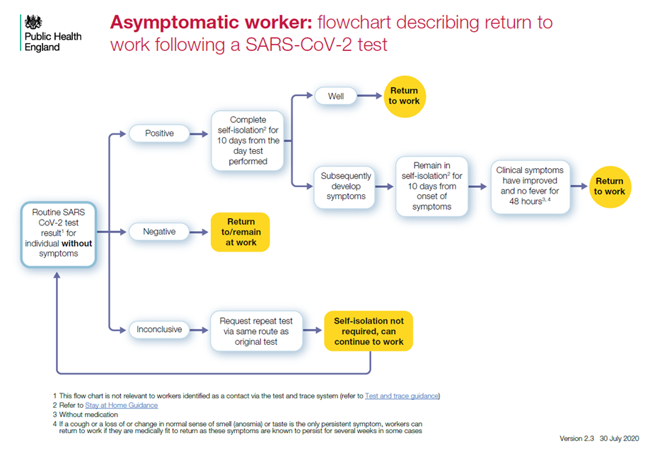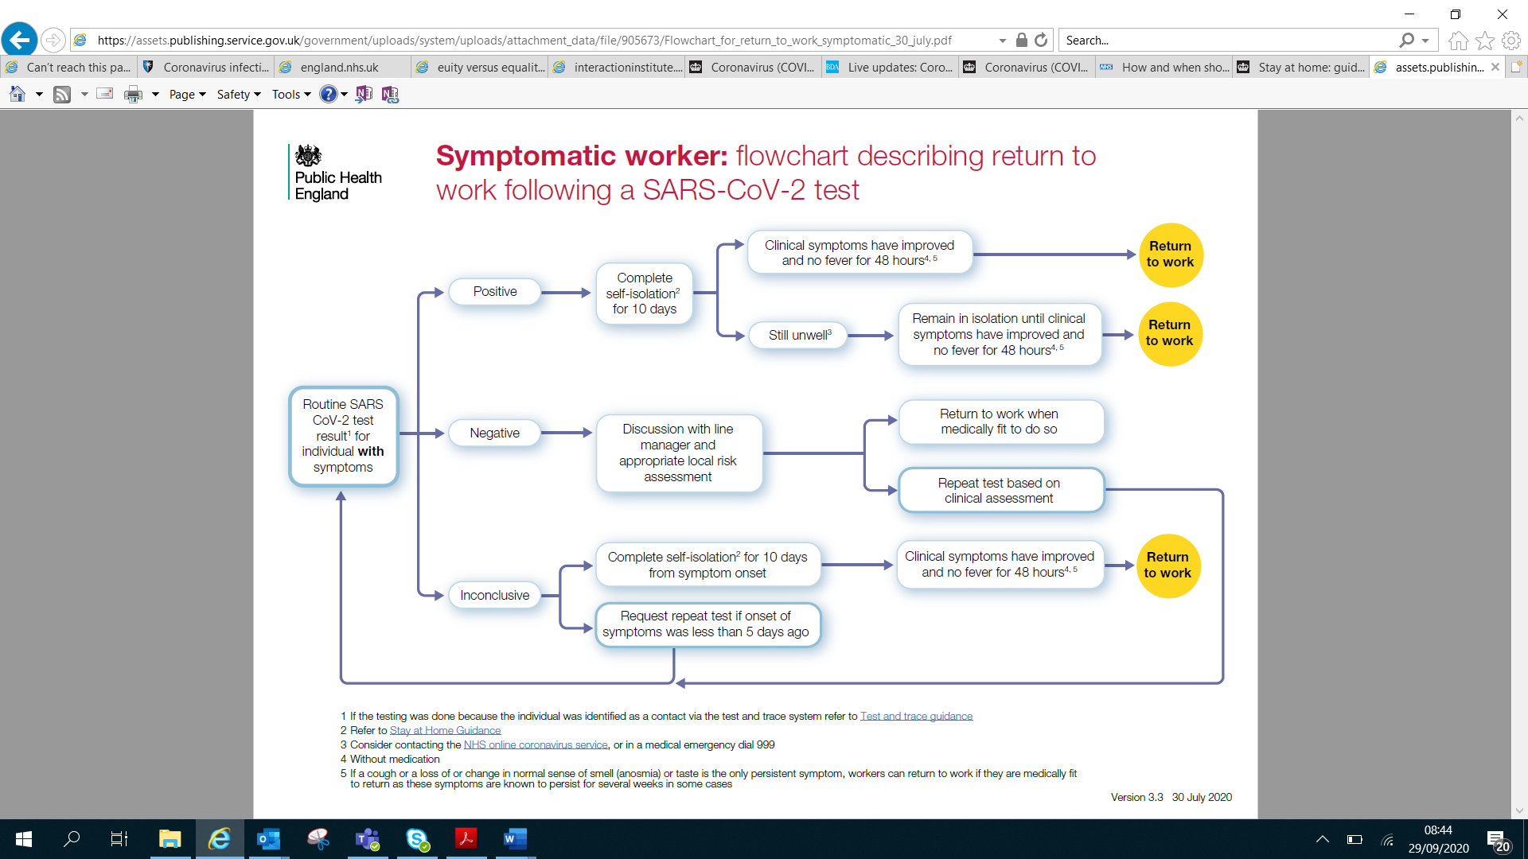[**https://www.gov.uk/government/publications/covid-19-management-of-exposed-healthcare-workers-and-patients-in-hospital-settings**](https://www.gov.uk/government/publications/covid-19-management-of-exposed-healthcare-workers-and-patients-in-hospital-settings)

**Appendix 2: Contact details for PHE and NHS EI**

**West Midlands**

**Public Health England**

Telephone: 0344 225 3560 – Option 0 then Option 2

Out of hours (via West Midlands Ambulance Service First Response): 01384 679031

Email*: [wm.2019cov@phe.gov.uk](mailto:wm.2019cov@phe.gov.uk)

*\*All urgent enquiries should be telephoned.*

**NHS EI**

Pharmacy email: [england.pharmacy-westmidlands@nhs.net](mailto:england.pharmacy-westmidlands@nhs.net)

Optometry email: [ENGLAND.Optometrycontractswm@nhs.net](mailto:ENGLAND.Optometrycontractswm@nhs.net)

Dental email: [england.dental-westmidlands@nhs.net](mailto:england.dental-westmidlands@nhs.net)

**East Midlands**

**Public Health England**

Telephone: 0344 2254 524, press the option the Health Protection Team

Email*: [ICC.EastMidlands@phe.gov.uk](mailto:ICC.EastMidlands@phe.gov.uk)

*\*All urgent enquiries should be telephoned.*

**NHS EI**

Pharmacy email: [england.eastmidspharmacy@nhs.net](mailto:england.eastmidspharmacy@nhs.net)

Optometry email: [england.eastmidsoptometry@nhs.net](mailto:england.eastmidsoptometry@nhs.net)

Dental email: [england.em-pcdental@nhs.net](mailto:england.em-pcdental@nhs.net)

**Appendix 3: Information your local PHE HPT may request from you:**

**Details of your pharmacy/practice**

• name of pharmacy/practice

• address (including postcode)

• key contact details: name, phone number, email

• nature of the pharmacy/practice environment (for example layout, nature of the building, entry/exit, communal areas)

• total number of staff

• number of staff who are clinically vulnerable or extremely clinically vulnerable

• number of staff isolating due to positive test of symptoms

• number of staff admitted to hospital due to COVID-19

• number of staff who have died due to COVID-19

**Details of the case**

• contact details of person/s affected

• when the individual(s) became unwell

• when they were last present in the pharmacy/practice

• nature of the roles/job/procedures undertaken by staff affected

• known links between the individual(s) with COVID-19 (in or out of the pharmacy/practice environment)

• number of people with which the individual(s) had close contact

**Details of control measures**

• Infection Prevention Control

• PPE

• Social distancing measures

• COVID-19 risk assessments (workplace, staff and patients)