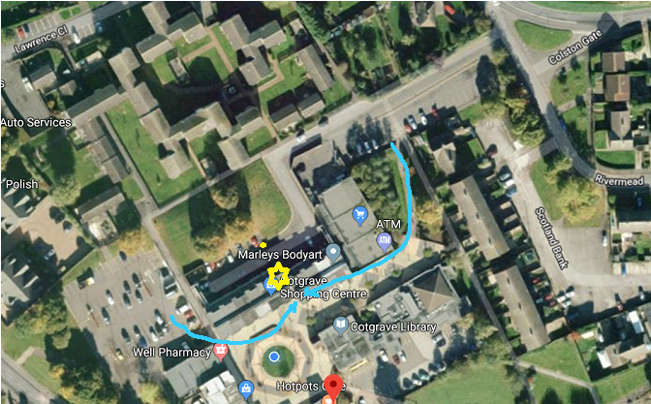

For SAT NAVs use the postcode – NG12 3JQ. This takes you to the shopping car park (to the left of the picture above) and then just walk through to the shopping precinct.

Once you arrive at the Cotgrave Business Hub you will need to buzz up to the LPC office – Press Number 5 and then press the button

